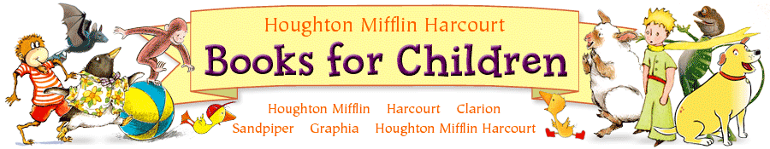

The literacy program that is used in our district is the Houghton Mifflin series. Each week the children will read a new story.

On Monday, new vocabulary will be introduced. This consists of words that will enrich their vocabulary. In addition, a read aloud will take place that promotes listening comprehension skills and verbal responses. The children will use the Smartboard to review their new words and a weekly phonic skill will be introduced. We will discuss the genre the story falls in and read about the author. A reading strategy is reviewed each week. The children will read a minibook in class, and will be reread for homework. These minibooks usually target a phonic skill and must be returned the following day. A coordinating comprehension sheet will also be issued that night for homework. Please encourage your child to LEAP back into the story to help them get the correct answers. You will receive a newsletter on Monday that explains the strategies and content that will be addressed this week. It is advised for your child to go on eduplace.com to review the new vocabulary in this unit.

On Tuesday, our new story will be introduced! The first time it is read this week, is usually on the rug with the children taking turns. Some weeks, the children read it to a partner or two! We finish the lesson by asking higher level comprehension questions that encourage the children to listen to the question, think about their answer, go back to the text to confirm their beliefs, and respond in a complete sentence. We also address the reading strategy that is targeted that week.

On Wednesday, the children hear the story for a second time and follow along as it is modeled for them on a CD. They are able to hear it read to them with proper pace and fluency. Our phonic skill that was introduced on Monday is reviewed again and appropriate workbook sheets are issued to the children depending on their proficiency.

On Thursday, we will combine writing and reading! The children incorporate what they learned from the story with the current writing strategy that is being covered in class. By linking this assignment to a familiar story, the children are able to make connections to the text. When completed, the children will conference with me and a few students may even get to share their work with the class!

On Friday, the children will have a comprehension assessment on the story. It will also address the reading strategy, new vocabulary, and phonics skills that were taught this week. This is not a test they can study for, but rather a snapshot to see what they were able to grasp over the course of the week. It provides me with the insight on how to gauge future instruction for your child. This weekly assessment will be sent home by Monday for you to look over.
